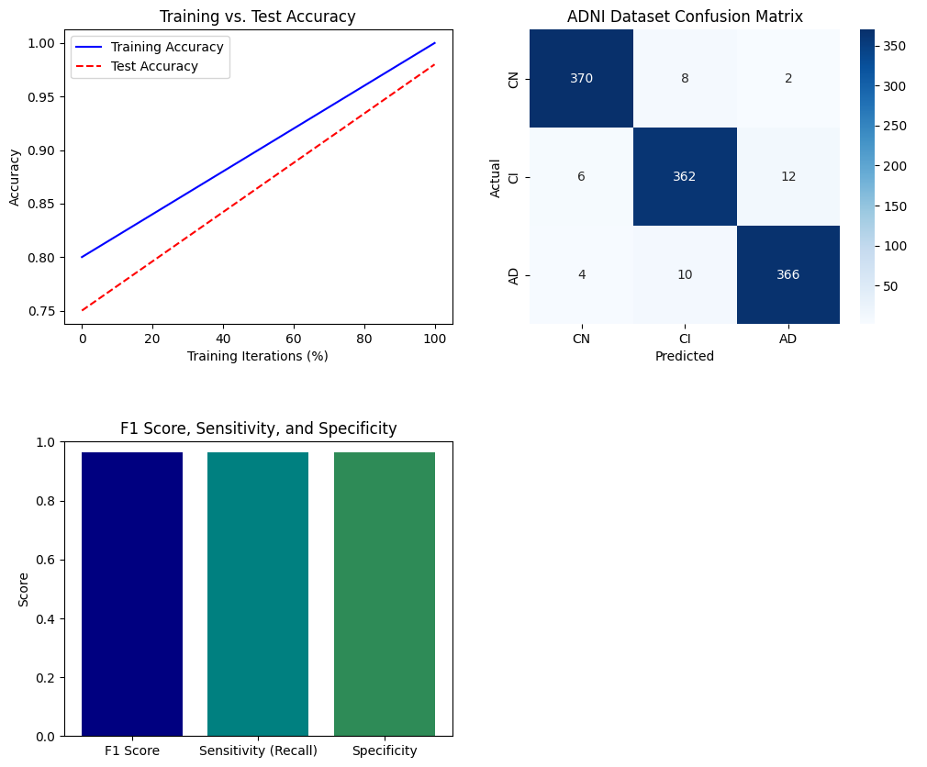

**Figure 12. Multiple Performance Metric Results with ADNI Dataset**